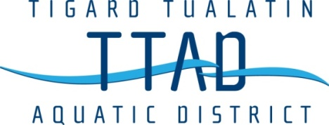

Meeting Notice
Board of Directors Meeting
October 21, 2020
6:00pm
This meeting will be held via Zoom
Meeting ID: 829 5612 0644, Password: s2ujz1

1. Call to Order
2. Approval of Minutes
3. Oral Communications from Audience (3 minutes per person)
4. Old Business
4.1 2020-21 Budget Review
4.2 SDAO Best Practices
5. New Business
5.1 Employee Pay Ranges
6. Aquatics Director Report
7 Written Communications
8. Remarks from Directors
9. Adjournment

