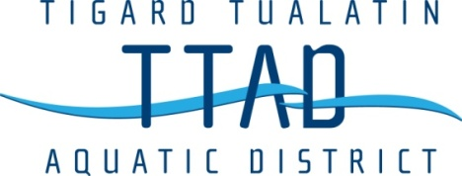

Meeting Cancellation Notice

The Board of Directors Meeting planned for April 16, 2024
will not be held

